# Software Development Life Cycle

Software Development Life Cycle (SDLC) is a process used by the software industry to design, develop and test high quality software’s. The SDLC aims to produce a high-quality software that meets or exceeds customer expectations, reaches completion within times and cost estimates.

A typical Software Development Life Cycle consists of the following stages −

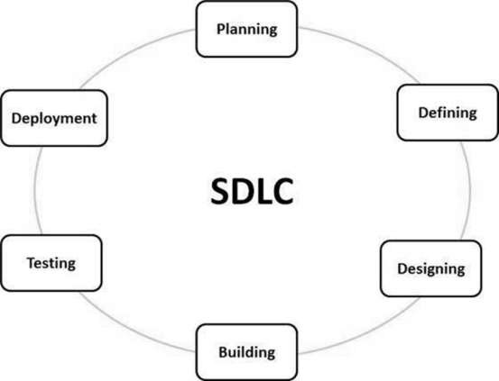

1. Planning and Requirement Analysis
2. Defining Requirements
3. Designing the Product Architecture
4. Building or Developing the Product
5. Testing the Product
6. Deployment in the Market and Maintenance

# Waterfall Model

The Waterfall Model was the first Process Model to be introduced. It is also referred to as a linear-sequential life cycle model. It is very simple to understand and use. In a waterfall model, each phase must be completed before the next phase can begin and there is no overlapping in the phases.

**Waterfall Model – Design:**

Waterfall approach was first SDLC Model to be used widely in Software Engineering to ensure success of the project. In "The Waterfall" approach, the whole process of software development is divided into separate phases. In this Waterfall model, typically, the outcome of one phase acts as the input for the next phase sequentially.

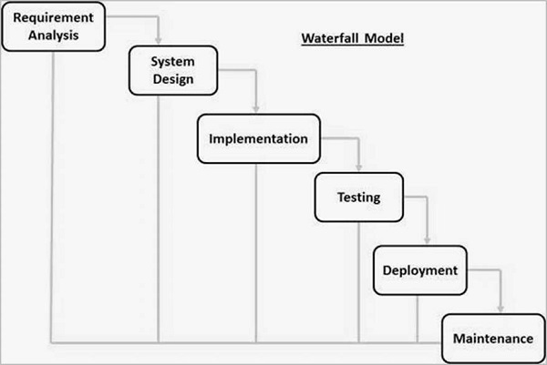

The sequential phases in Waterfall model are −

* **Requirement Gathering and analysis** − All possible requirements of the system to be developed are captured in this phase and documented in a requirement specification document.
* **System Design** − The requirement specifications from first phase are studied in this phase and the system design is prepared. This system design helps in specifying hardware and system requirements and helps in defining the overall system architecture.
* **Implementation −** With inputs from the system design, the system is first developed in small programs called units, which are integrated in the next phase. Each unit is developed and tested for its functionality, which is referred to as Unit Testing.
* **Integration and Testing** − All the units developed in the implementation phase are integrated into a system after testing of each unit. Post integration the entire system is tested for any faults and failures.
* **Deployment of system −** Once the functional and non-functional testing is done; the product is deployed in the customer environment or released into the market.
* **Maintenance −** There are some issues which come up in the client environment. To fix those issues, patches are released. Also to enhance the product some better versions are released. Maintenance is done to deliver these changes in the customer environment.

All these phases are cascaded to each other in which progress is seen as flowing steadily downwards (like a waterfall) through the phases. The next phase is started only after the defined set of goals are achieved for previous phase and it is signed off, so the name "Waterfall Model". In this model, phases do not overlap.

**Waterfall Model - Application**

Every software developed is different and requires a suitable SDLC approach to be followed based on the internal and external factors. Some situations where the use of Waterfall model is most appropriate are −

* Requirements are very well documented, clear and fixed.
* Product definition is stable.
* Technology is understood and is not dynamic.
* There are no ambiguous requirements.
* Ample resources with required expertise are available to support the product.
* The project is short.

# Iterative Model

In the Iterative model, iterative process starts with a simple implementation of a small set of the software requirements and iteratively enhances the evolving versions until the complete system is implemented and ready to be deployed.

An iterative life cycle model does not attempt to start with a full specification of requirements. Instead, development begins by specifying and implementing just part of the software, which is then reviewed to identify further requirements. This process is then repeated, producing a new version of the software at the end of each iteration of the model.

**Iterative Model - Design**

Iterative process starts with a simple implementation of a subset of the software requirements and iteratively enhances the evolving versions until the full system is implemented. At each iteration, design modifications are made and new functional capabilities are added. The basic idea behind this method is to develop a system through repeated cycles (iterative) and in smaller portions at a time (incremental).

The following illustration is a representation of the Iterative and Incremental model −

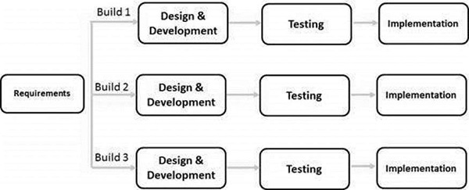

Iterative and Incremental development is a combination of both iterative design or iterative method and incremental build model for development. "During software development, more than one iteration of the software development cycle may be in progress at the same time." This process may be described as an "evolutionary acquisition" or "incremental build" approach."

In this incremental model, the whole requirement is divided into various builds. During each iteration, the development module goes through the requirements, design, implementation and testing phases. Each subsequent release of the module adds function to the previous release. The process continues till the complete system is ready as per the requirement.

The key to a successful use of an iterative software development lifecycle is rigorous validation of requirements, and verification & testing of each version of the software against those requirements within each cycle of the model. As the software evolves through successive cycles, tests must be repeated and extended to verify each version of the software.

**Iterative Model - Application**

Like other SDLC models, Iterative and incremental development has some specific applications in the software industry. This model is most often used in the following scenarios −

* Requirements of the complete system are clearly defined and understood.
* Major requirements must be defined; however, some functionalities or requested enhancements may evolve with time.
* There is a time to the market constraint.
* A new technology is being used and is being learnt by the development team while working on the project.
* Resources with needed skill sets are not available and are planned to be used on contract basis for specific iterations.
* There are some high-risk features and goals which may change in the future.